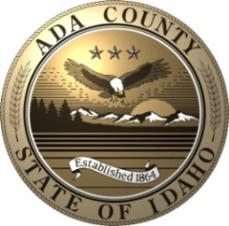Strategic Plan for Sustainable Operations

SORC -

Sustainable

Operations

and

Resource

Conservation

and Resource Conservation

Vision

To effectively and responsibly manage Ada County’s resource use and conservation practices while being good stewards of the environment. To maximize social and economic possibilities by providing a safe, productive, and sustainable working environment for County employees.

Mission

Expanding on the mission of Ada County Operations, the mission of the Sustainable Operations and Resource Conservation (SORC) plan is to implement creative, cost-effective strategies to control resource use, save tax dollars, and meet the demands of a growing population without compromising the needs of future generations through a partnership of people, policies, and actions.

Philosophy

Sustainability can be described in a variety of ways. According to the Environmental Protection Agency, “Everything that we need for our survival and well-being depends, either directly or indirectly, on our natural environment. Sustainability creates and maintains the conditions under which humans and nature can exist in productive harmony that permits fulfilling the social, economic and other requirements of present and future generations.” Sustainability is most often defined as “using resources to meet the needs of the present without compromising the ability of future generations to meet their own needs.”

Current trends demonstrate the need to create healthy, safe, and sustainable communities. Ada County recognizes that being as resource efficient as possible is essential to stay ahead of the curve to control costs and maintain our status as good leaders.

With the long-term success and health of Ada County in mind, it is our commitment to lead by example and incorporate sustainability into the daily operations of Ada County by proactively identifying and implementing methods that improve building efficiency, lessen energy consumption, reduce waste, and conserve natural resources. The strategic plan establishes Ada County’s conservation and resource use goals and initiatives for all Ada County-owned facilities.

With over 1600 employees and more than 1.3 million square feet of County facilities, wise use of resources in public buildings will effectively reduce utility bills while creating a healthy indoor environment for building occupants. We also believe that energy-efficient building design and construction practices, countywide recycling programs, and the proper disposal of waste within the County will improve the community's environment. These benefits cannot be realized without the support of staff across our organization. The SORC Plan Partnership consolidates Ada County’s commitment to the environment and provides for public participation in the process.

A healthy environment is directly related to the efficient use of natural resources via energy-efficient building design and construction and responsible operating practices. Ada County demonstrates to employees and the community that its buildings are operated in a cost-effective manner, saving resources and tax dollars. Management and staff work together to accurately measure energy efficiency and develop a phased approach for efficiency improvements.

Overall Objectives

The objectives of the SORC benefit all citizens of Ada County and should meet the needs of the County Commissioners, Elected Officials, department heads, employees, maintenance staff, and all County building occupants.

**ADMINISTRATIVE**

* Align Ada County’s overall mission to serve the public good with expanding and growing the concept of sustainability
* Promote and facilitate the Ada County SORC Plan Partnership
* Establish benchmarks to foster the development of precise, tangible goals that can be quantitatively monitored and measured with set indicators and outcomes

**BUILDINGS, ENERGY USE, AND RENEWABLES**

* Build, operate, and maintain high performance buildings to ensure that conservation and responsible resource use remains a priority for Ada County
* Create healthy work spaces for optimal occupant health and comfort
* Limit, control, and lower utility costs
* Explore a Revolving Energy Fund to use energy savings for future projects
* Promote and expand the use of renewable energy within the County

**TRANSPORTATION AND FUEL**

* Decrease emissions and fuel consumption from county-owned vehicles
* Promote infrastructure development and the use of alternative fuels
* Promote alternative transportation for county employees
* Support the Parks and Waterways Department in maintaining bike paths and trails within the county

**PROCUREMENT, RECYCLING, AND WASTE MANAGEMENT**

* Coordinate with the Procurement Department to adopt environmentally preferable purchasing (EPP) practices
* Assist Information Technology in developing best management practices (BMP)’s for equipment purchases
* Increase recycling rates and promote waste reduction in County operations
* Improve and expand options for recycling at the Landfill

**OUTREACH AND EDUCATION**

* Create a Best Practices Plan for cleaning services, landscaping crew, and building occupants on resource use and energy conservation and share with stakeholders
* Promote sustainability internally to County employees throughout all departments
* Proactively promote public image and sustainability initiatives externally to Ada County residents
* Foster peer exchange through meetings with other counties, building owners, maintenance staff, etc. to share ideas

Issues and Challenges

Following are major issues and challenges affecting the organization, now and in the future. They are potential barriers to effective program implementation:

* Successfully engaging SORC Plan Partners and County employees in the implementation of strategies and goals
* Appropriation of adequate resources, staff, partners, and dollars to produce effective and timely implementation of measures
* Increasing utility costs and limited funds available for projects and programs
* Population growth increasing demands on facilities and driving up maintenance costs
* Allocating sufficient resources for the Preventative Maintenance Program to keep building systems operating at maximum efficiency
* Providing advanced training for building operators to maintain highly engineered, specialized building systems

Organization and Responsibilities

The Partnership is supported from the top down beginning with the Board of Ada County Commissioners. Financial support comes through the established County budgetary process. The continuing planning process is designed to bring on-going support from partners and other stakeholders as they are identified.

**Director of Operations**

The Director of Operations is the lead for the County Partnership. The Director provides the focus, leadership, staff and monetary resources to support the development and implementation of a successful program.

**Energy Specialist**

The Ada County Energy Specialist reports to the Director of Operations and is the lead for updating and implementing the County's action plan. Responsibilities also include:

* Maintaining utility management software and databases
* Tracking utility costs and rate changes for budgeting purposes
* Recommending operation and maintenance, resource, and efficiency changes
* Providing measurement and verification reports for retrofit projects
* Coordinating project and data requirements for LEED certification
* Tracking energy generation and revenue from renewable energy projects

**Building Maintenance and Custodial Staff**

County building maintenance and custodial personnel are responsible for carrying out the day-to-day operation and maintenance activities and are involved in the development and implementation of planned activities which can produce significant cost savings.

**Building Occupants**

Each building occupant is important to the success of the program, though not specifically listed as a partner. Behavior such as turning off unused lights and equipment etc., can reduce building energy use by 10% and significantly reduce energy costs.

**Plan Partners**

Plan Partners are specifically recruited and selected from County departments and outside businesses to bring their particular expertise and experience to the program. Each partner is requested and challenged to assist Ada County in determining both short and long range goals and objectives that can be accomplished.

As Energy Plan Partners, they may provide program recommendations, technical support, or resources and services that are both in-kind or for pay. Partners may use portions of the plan or the information contained in it for newsletters and publications to promote the program and their contributions towards its success.

**CURRENT PLAN PARTNERS**

**Ada County Staff Department / Position**

Bob Batista Director of Expo Idaho

Dawn Burns Director of Juvenile Court Services

Jeremiah Cameron Operations, Facility Maintenance Superintendent

Elizabeth Duncan Communications Manager

Jean Fisher Family Advocacy Cntr & Education Svcs (FACES)

Zach Kirk Development Services, County Engineer

Kurt Hunt Director of Solid Waste

Kendra Kenyon Board of Ada County Commissioners

Scott Koberg Director of Parks and Waterways

Bruce Krisko Deputy Director of Operations

Diana Lachiondo Board of Ada County Commissioners

Meg Leatherman Director of Development Services

Selena O'Neal Operations, Energy Specialist

Stephen O’Meara Director of Information Technology

Bob Perkins Director of Purchasing

Katie Reed Director of Indigent Services

Adam Schroeder Director of Weed, Pest, and Mosquito Abatement

Tobe Thompson Operations, Construction Manager

Rick Visser Board of Ada County Commissioners

Darby Weston Director of Paramedics

Scott Williams Director of Operations

Mike Work Operations, Maintenance Manager

**Business Partners Company / Organization**

Greg Allen Hummel Architects

Ken Baker Integrated Design Lab

Lori Blattner Intermountain Gas Company

Doug Cooper McKibben+Cooper Architects

Karen Danley Stakeholder and County Resident

Mike Doyle Hardin Sanitation

Ken Gallegos LCA

Jami Goldman City of Boise, Public Works

Jon Gunnerson City of Boise, Public Works

Geoff Johnson Eidam & Associates

Bill Kissinger ATS Inland NW

Rachele Klein Republic Services

Jane Kreller Suez

Rick McCormick Jacobs Engineering

Melanie Pinkston Idaho Power

Scott Pugrud Idaho Office of Energy Resources

Ahren Tryon LFG Development

Bryan Wewers Idaho Power

Mike Wisdom Engineering Inc

Annual Strategic Plan Review

The County relies on its in-house expertise along with local business partners such as utility representatives, architects, engineers and other local professionals to provide input from their unique perspectives and ensure a more comprehensive plan. The business partners include professional service and business organizations that have an investment in the community. The Partners meets annually to review the goals and tasks planned for the fiscal year. The plan is reviewed at a predetermined public meeting where updates are also provided on the accomplishments and successes achieved in the previous year.

County Facilities

Ada County owns and operates diverse portfolio of buildings to provide a variety of services to the general public, along with office space for its employees. Each facility is continually monitored and assessed, on an individual basis, to identify ways to make them more energy efficient.

**Major County facilities:**

* Courthouse and Administration Building
* Public Safety Building and Field Services
* County Jail, Medical Unit, and Work Release Center
* Juvenile Court Services and Detention Facility
* Barber Park Administration Building, Raft Rental, and Event Center
* Expo Idaho (Western Idaho Fairgrounds)
* Solid Waste Management Landfill Office and Hazardous Waste Building
* Weed, Pest, and Mosquito Abatement Facility
* Morris Hill Morgue and Storage Facility
* The Justice Center / FACES
* Benjamin Bldg: Elections, Vehicle Licensing, Adult Drug Court, Juvenile Programs
* Paramedics Administration and Training Facility
* Paramedics Emergency Medical Stations
* 911 Dispatch Center

Energy Tracking and Reporting

Monthly utility billing information for electricity, natural gas, water, sewer, and trash is entered in Utility Manager software to establish a baseline of energy use for each building. The data is used to identify and prioritize buildings with high utility costs, determine potential energy-saving measures, evaluate future energy and resource use and savings, and assess post-improvement performance of retrofitted buildings.

Energy Use Index

An Energy Use Index is published for the major facilities to measure its energy performance on a per square foot basis. It is used to establish baseline energy consumption and quantify subsequent savings from Energy Conservation Measures. A current energy use index can be found in the section on Buildings and Energy Use.

Building Assessments

Building assessments may be conducted on the County buildings using a variety of resources. Assessments identify specific building-by-building O&M's for maintenance staff implementation. Priority is based on analysis of utility data, County needs, and financial capabilities.

**Selection criteria for building assessments:**

* The potential of implementing effective ECMs that result in building energy savings
* An estimate of time and dollars needed to perform the measures
* The availability of time and resources to devote to the project

Assessments include an in-depth analysis of the whole building including the building envelope, lighting and control systems, engineering analysis of mechanical systems such as air flows and equipment operating efficiencies, metered water use and sewer billing, and trash records.

Under the direction of the Energy Specialist, a contract engineer may lead the assessment team along with County staff. An assessment report will be prepared with recommendations for ECM actions for the County's consideration. Life cycle cost analysis will be utilized for ECM assessment to facilitate Ada County in optimizing their return on investment. A 20% IRR (internal rate of return) is the goal for each project.

**Assessment reports include:**

* Recommended ECM's
* An estimated cost for ECM implementation and calculation of ECM simple payback
* Life Cycle Costing optimization where appropriate
* Identification of existing operating efficiencies
* Identification of funding options for measure implementation
* Identification of Operations & Maintenance's (O & M's)
* Recommendation to reduce water consumption and sewer bills
* Recommendation to reduce trash volumes and costs

Building Retrofits

Building retrofits can generate savings that enable the County to purchase new equipment, add new employees, or expand existing programs. In most circumstances, when retrofit objectives are identified in advance, the objectives can be incorporated and completed with other remodeling projects and building additions.

Retrofit projects designed to increase the efficiency of building systems will positively affect concerns that are important to Ada County officials. Concerns such as:

* Building safety
* Comfort and productivity of occupants
* Increased employee productivity
* Reductions in system failures
* Expansion of anticipated life-cycle or intended use
* Reduced maintenance and utility costs

Major Accomplishments in 2018-2019



GOALS FOR 2019-2020



**GENERAL Goals and OBJECTIVES FOR 2019-2020**

The objectives of the SORC as summarized on page 2 are categorized and explained in more detail in the remainder of the report as follows:

AdministratiVE Goals Page 11

BUILDINGS, ENERGY USE, AND RENEWABLEs GOALs Page 12

transportation and fuel Goals page 23

Procurement, Recycling, & Waste Goals Page 25

Outreach & Education Goals Page 26

Refer to the supporting in pages in each category for more information.

**AdministratiVE Goals**

Adapt the existing framework of County Operations’ policies and procedures into a solid foundation for progression into sustainability and resource efficiency. Promote sustainability through partnerships, education and program development. To devise an evaluation system complete with outcome indicators and measurable metrics. Accomplish the mission of the SORC in an accountable manner though effective use of staff time and energy, proper governance and appropriate resource allocation.

OBJECTIVES

* Align the overall mission of Ada County of serving the public good with expanding and growing the model of sustainability
* Establish benchmarks to foster the development of precise, tangible goals that can be quantitatively monitored and measured with set indicators and outcomes
* Promote and facilitate the Ada County SORC Plan Partnership

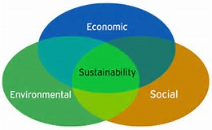TASKS TO SUPPORT OBJECTIVES

* Coordinate with elected officials and department heads to establish commitment and a framework for concrete goals
* Develop and implement a framework for progress and evaluation
  + Provide data tracking and continuous commissioning associated with operation and occupancy of all County facilities
  + Develop a responsibility breakdown
  + Explore the feasibility of pursuing STAR certification
  + Frequently reassess to ensure advancements towards targets are realistic and achievable
* Align SORC cohesively with 2025 Ada County Comp Plan
* Provide administration and oversight to quantify benefits and savings of energy conservation projects at County facilities
* Identify and create proactive solutions for obstacles that may inhibit staff and departments from achieving goals
* Adopt a formal charter with defined expectations for membership in SORC Plan Partnership
* Utilize SORC Plan Partnership as a working group to promote sustainability within County
* Explore the utilization of varied certifications, benchmarking tools, and checklists
* Track Ada County’s ecological footprint
  + Inventory and monitor greenhouse gas emissions from building energy use, transportation fuel use, and waste generation for emissions inventory
  + Quantify offsets from alternative transportation, green buildings, renewable energy, and recycling programs
  + Stay abreast of developments in greenhouse gas and emissions reporting requirements
  + Report periodically on progress to stay on track and provide accountability
  + Conduct a retroactive annual emissions inventory to track trends in consumption

**BUILDINGS, ENERGY USE, AND RENEWABLEs GOALs**

Support high performance County buildings and efficient landscapes through green construction, operation, and maintenance practices to realize economic and resource savings, demonstrate responsible use of taxpayer dollars, and improve markets for environmentally friendly products and practices. Promote and expand the County’s use of unique regional renewable energy.

OBJECTIVES

* Limit, control, and lower utility costs
* Make County facilities as energy and resource efficient as reasonably possible
* Build, operate, and maintain high performance buildings to ensure that conservation and responsible resource use remains a priority for Ada County
* Support high performance green buildings
* Create healthy work spaces for optimal occupant health and comfort
* Promote and expand renewable energy

TASKS TO SUPPORT OBJECTIVES

* Track consumption and costs of electricity, natural gas, water, sewer, and trash
* Assess ways to reduce peak load in the summer
* Perform night walks to observe buildings after-hours
* Maintain annual Energy Use Index for buildings 10,000+ sf
* Update, install, or retrofit lighting and HVAC systems with energy efficient options wherever feasible
* Evaluate data to document savings from retrofits
* Benchmark buildings with ENERGY STAR’s Portfolio Manager
* Apply for ENERGY STAR label for eligible buildings
* Conduct energy audits and facility assessments to identify necessary building operation and efficiency improvements
* Invest in facilities, equipment, and other goods that reflect the highest feasible efficiency and lowest life cycle costs
* Incorporate WaterSense programs into Ada County facilities
* Provide Building Operator Certification for maintenance staff
* Develop regular maintenance and comprehensive preventive maintenance programs and schedules for all County facilities
* Incorporate building commissioning into construction projects
* Recommission buildings as necessary
* Support the Idaho Energy and Green Building Conference
* Be an advocate for the US Green Building Council.
* Provide information and case studies for County LEED projects
* Have a LEED Accredited Professional on staff
* Increase the overall comfort and productivity of staff
* Manage indoor air quality in all occupied spaces
* Evaluate energy conservation measures (ECMs) for all facilities
* Participate in local utility incentive programs
* Explore a Revolving Energy Fund to use energy savings for additional projects
* Use sustainable landscaping practices to reduce water use
* Seek grants and other funding for solar projects on County facilities
* Participate in EPA’s Landfill Methane Outreach Program
* Measure and verify landfill gas (LFG) quality and quantity
* Ensure landfill gas to energy (LFGTE) generator complies with contractual obligations to provide revenue documentation
* Assist with expansion of the landfill gas to energy project

# Energy Use INdex (EUI)

**What is an EUI?**

An Energy Use Index is a basic measure of a facility’s energy performance on a per square foot basis. It is typically measured as kBTUs of energy used annually per square foot. A BTU, British Thermal Unit, is a basic measure of heat value (energy content) of fuels. All energy consumed by a particular building; i.e., electricity, natural gas, etc., is converted to thousand BTU’s, added together, and divided by the total square footage.

Below is a current EUI chart for most of Ada County’s buildings. Generally, a low EUI signifies good energy performance. 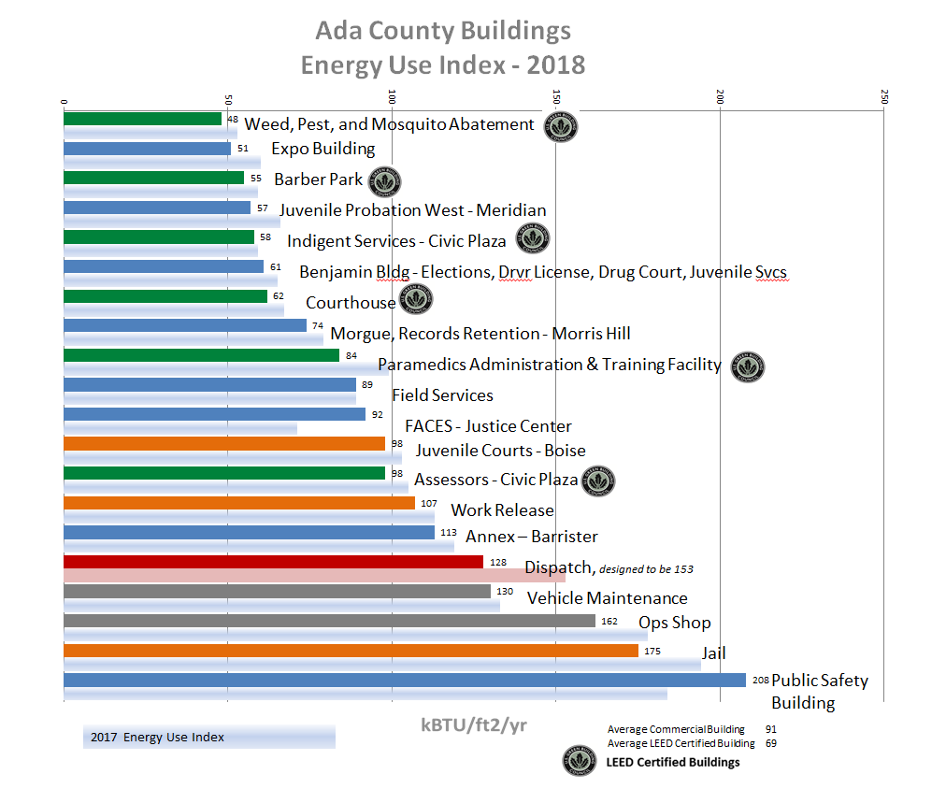

Certain building types will always use more energy than others. For example, a park building with seasonal use requires relatively little energy compared to a paramedic station that operates 24/7. Similarly, a small office building with 50-100 employees will use less energy than a jail facility that supports nearly 1,000 people on a continual basis.

# UTILITY INCENTIVES

Efficiency programs not only save the County money, but also defer the need to build new power plants and prevent the utility from acquiring power from more expensive sources to meet growing customer demand. Ada County takes advantage of Idaho Power’s incentive programs in any new or remodel building project.

|  |  |  |  |  |  |
| --- | --- | --- | --- | --- | --- |
| |  | | --- | |  | |  |  |  |  |
| **Location** |  | **Incentive** |  | **Measures** |
| **FY 09-10** |  | **$12,613** |  | **Lighting, AC, Roofing, Windows** |
| **FY 10-11** |  | **$13,129** |  | **Lighting, AC, Roofing, Windows, Controls** |
| **FY 12-13** |  | **$21,557** |  | **HVAC Controls, Roofing, Var Speed Drives** |
| **FY 13-14** |  | **$24,007** |  | **LED Lighting** |
|  |  |  |  |  |
| **Paramedics Admin, 370 Benjamin** |  | **$188** |  | **LED Lighting Upgrade** |
| **Juvenile Detention, Boise** |  | **$5,321** |  | **LED Lighting Upgrade** |
| **Expo Idaho Admin and Entrance** |  | **$3,039** |  | **Lighting, HVAC, Roofing, Appliances** |
| **Paramedics Station 17, Ridenbaugh** |  | **$2,922** |  | **Lighting, HVAC, Roofing, Appliances** |
| **FY 14-15** |  | **$11,470** |  |  |
|  |  |  |  |  |
| **Morris Hill Warehouse** |  | **$520** |  | **Exit Signs** |
| **Morris Hill Warehouse** |  | **$721** |  | **Exterior Lighting Upgrade (4) 400w MH wall packs** |
| **Juvenile Meridian** |  | **$3,305** |  | **Lighting, AC, Roofing, Controls, Appliances** |
| **400 Benjamin** |  | **$3,574** |  | **Lighting (7) Exterior Wall Packs & (8) Pole Lights** |
| **FY 15-16** |  | **$8,120** |  |  |
|  |  |  |  |  |
| **Courthouse Exterior Lights** |  | **$1,200** |  | **LED Lighting Upgrade, (20) 100w MH exterior lights** |
| **Expo Idaho Maintenance Shop** |  | **$561** |  | **Lighting Upgrade, 8' T12s to 4' T8s** |
| **Juvenile Meridian** |  | **$359** |  | **LED Lighting Upgrade, (3) 250w MH parking lot lights** |
| **911 Dispatch** |  | **$23,186** |  | **Lighting, AC, Roofing, Controls** |
| **911 Dispatch** |  | **$39,409** |  | **Non Lighting, HVAC only** |
| **Weed & Pest Addition** |  | **$1,612** |  | **Lighting, AC, Roofing 2100 sf** |
| **Jail Roof** |  | **$472** |  | **Roofing 9,439 sf @ $0.05/sf** |
| **Morris Hill Roof** |  | **$598** |  | **Roofing 11,960 sf @ $0.05/sf** |
| **Juvenile Occupancy Sensors** |  | **$350** |  | **Lighting** |
| **Public Safety Building Complex** |  | **$111** |  | **Notched V-Belts, $5/hp - total of 16.5 hp** |
| **FY 16-17** |  | **$67,858** |  |  |
|  |  |  |  |  |
| **Public Safety Building Complex** |  | **$125** |  | **Notched V-Belts, $5/hp - 25 hp** |
| **Public Safety Building Complex** |  | **$642** |  | **Notched V-Belts, $5/hp - 172.75 hp (capped at cost of belts)** |
| **Hazardous Waste Facility** |  | **$883** |  | **LED Lighting Upgrade - 12 exterior lights** |
| **Landfill** |  | **$1,407** |  | **LED Lighting Upgrade - 8 pole lights** |
| **Emergency Operations Center** |  | **$381** |  | **LED Lighting Upgrade - 28 T5 fixtures** |
| **Courthouse Lobby** |  | **$1,246** |  | **LED Lighting Upgrade - 79 Canned lights** |
| **Landfill Shop** |  | **$398** |  | **LED Lighting Upgrade - 7 interior 4' T12s** |
| **Barber Park** |  | **$362** |  | **LED Lighting Upgrade - 6 175w exterior pole lights** |
| **FY 17-18** |  | **$5,444** |  |  |
|  |  |  |  |  |
| **Landfill Hangar** |  | **$2,376** |  | **LED Lighting Upgrade - 12 High Bay 1000w Metal Halides** |
| **Coroner's Autopsy Room** |  | **$1,847** |  | **LED Lighting Upgrade** |
| **FACES Community Room** |  | **$222** |  | **LED Lighting Upgrade** |
| **Work Release** |  | **$1,104** |  | **LED Lighting Upgrade** |
| **Juvenile Dorms** |  | **$434** |  | **LED Lighting Upgrade - 44 4ft 62w T8s** |
|  |  |  |  | **Also upgraded nightlights w/out incentives** |
| ***Courthouse Stairwells*** |  | ***$2,158*** |  | ***LED Lighting Upgrade*** |
| ***Landfill Hangar*** |  | ***$1,571*** |  | ***LED Lighting Upgrade*** |
| **FY 18-19** |  | **$9,712** |  |  |
|  |  |  |  |  |
| **TOTAL 2009-2019** |  | **$173,910** |  |  |
| ***Italicized projects are pending*** |  |  |  |  |

# Utility Summary

The Ada County Operations Department now manages, maintains, and pays utilities for nearly 1.3 million sf of building space and more than 250,000 sf of parking facilities. Nearly 25,000 sf of building space was added with the addition of the 911 Dispatch Center in Meridian. In 2018, a new 3,800 sf Paramedic station opened on Liberty Street in Boise, near St Alphonsus Regional Medical Center.

The total cost to the County for all utilities combined in FY18-19 decreased 5.1%, or $109,459, compared to the previous fiscal year. See the charts below for more information.



**The following graphs compare usage and costs for the major utilities; i.e., electricity, natural gas, water, sewer, trash, for all County buildings combined for calendar years 2017 and 2018.**

Monthly Electricity Use for Ada County

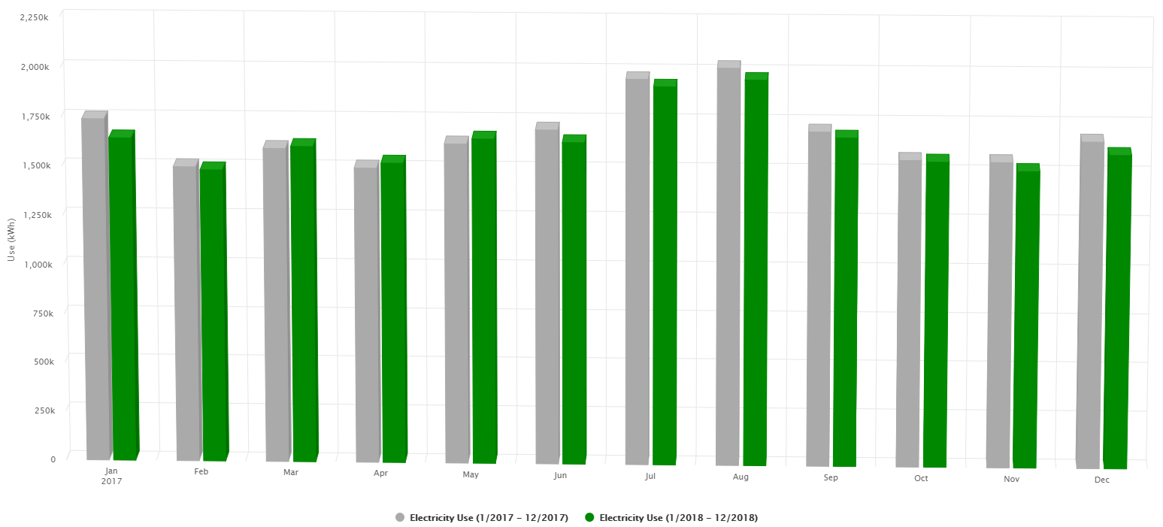

Electricity Usage 2% Decrease

Electricity Costs 4% Decrease

Monthly Natural Gas Use for Ada County

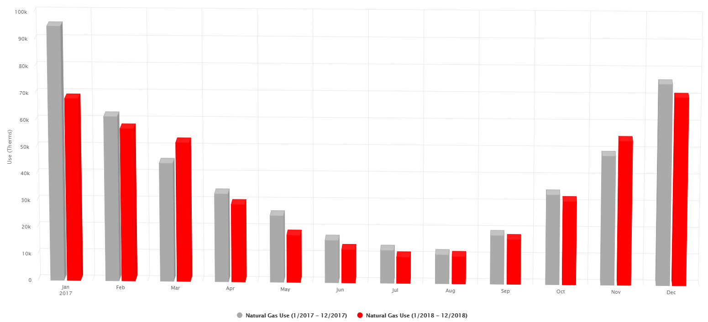

Natural Gas Usage 9% Decrease

Natural Gas Costs 20% Decrease

Monthly Water Use for Ada County

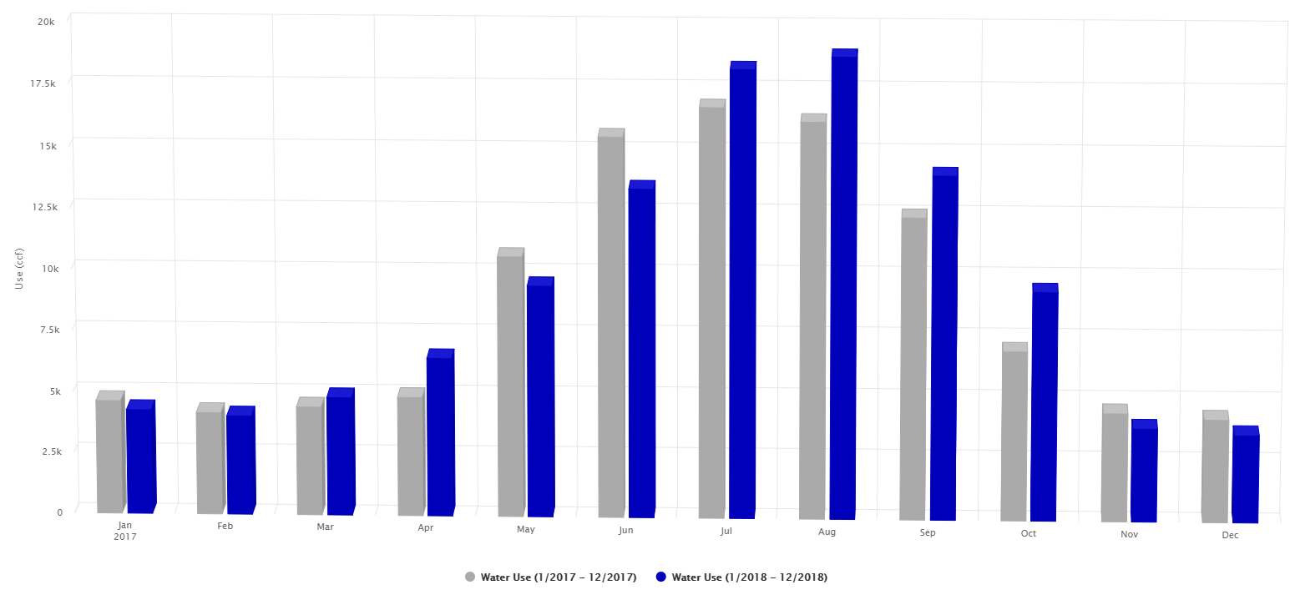

Water Usage 6% Increase

Water Costs 2% Increase

Monthly Sewer Use for Ada County

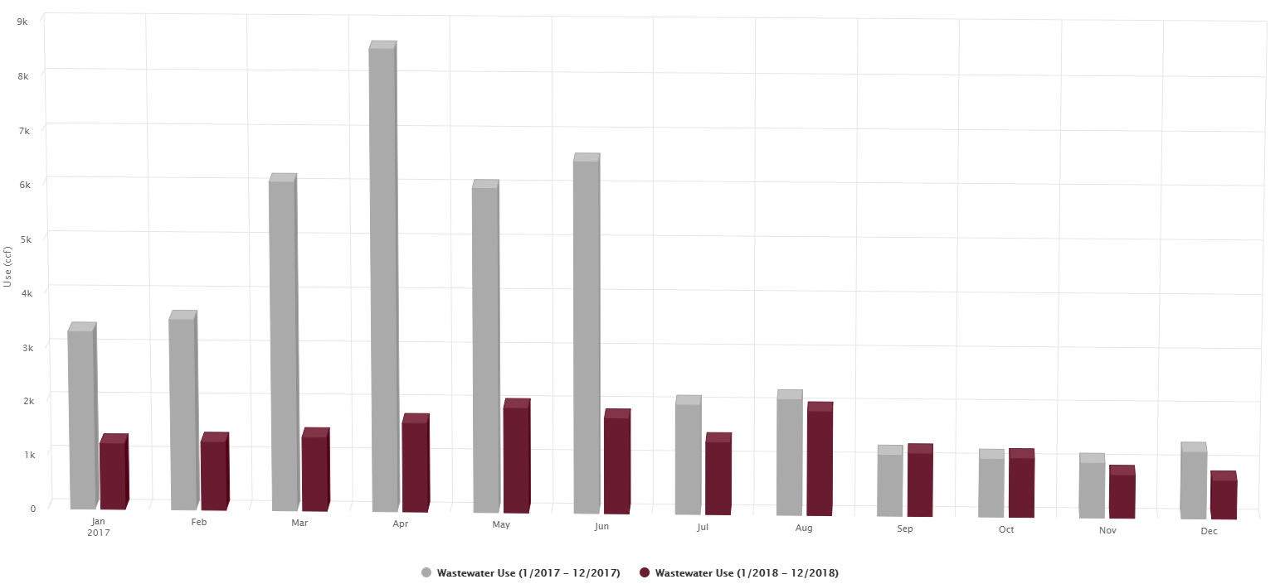

Sewer Usage 62% Decrease

Sewer Costs 5% Increase

Monthly Refuse Use for Ada County

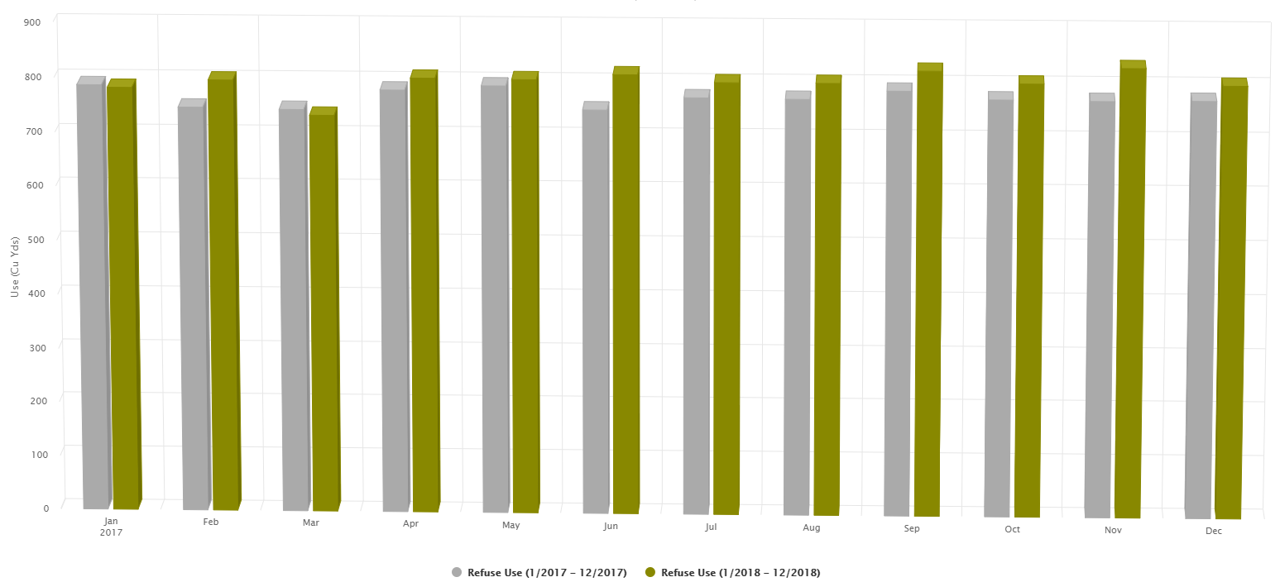

Trash Usage 4% Increase

Trash Costs 3% Increase



# Photovoltaic (PV) power – barber park

Ada County has an 11.5 KW solar photovoltaic (PV) system on the rooftop of the Barber Park Administration Building that is net-metered by Idaho Power. Each year hundreds of people launch their rafts and inflatables to float the scenic Boise River. Ada County maintains a launch site at Barber Park complete with free air pumps. The solar energy generated by the PV system offsets these costs with “free” energy from the sun.

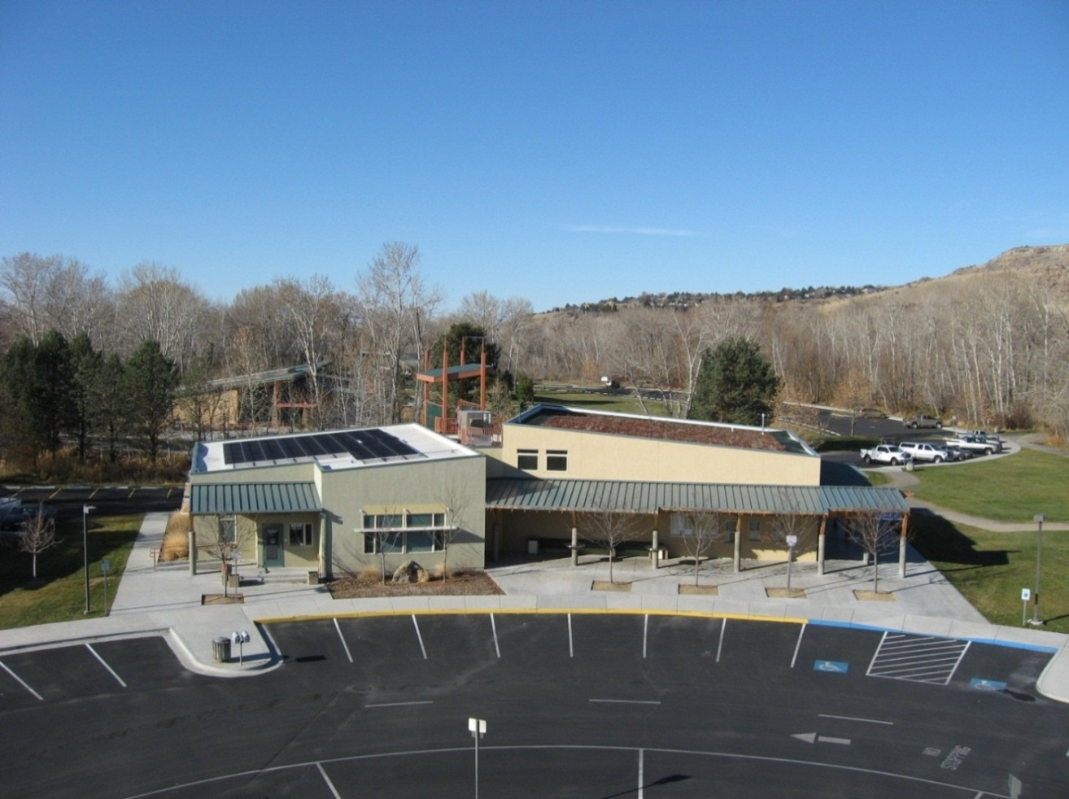

The system was designed and installed in September 2011 using federal grant money from the American Recovery and Reinvestment Act. It generated 12,369 kWh in calendar year 2017 and 13,936 kWh in 2018, with an estimated annual value of approximately $1,200.

Solar PV System Specs:

60 Solyndra Panels, @ 191 watts

1 Midnight Solar Combiner Box

2 5000-US SMA Inverters

1 SMA Sunny WebBox Monitoring System

Hydroelectric power – barber Dam

The Barber Dam is a timber-crib dam on the Boise River located about 3 mi (5 km) east of Boise, Idaho. The dam was constructed between 1904 and 1906 to serve as a mill pond for timber. A power plant was also constructed in conjunction with the dam to power the mill and the town of Barberton (Barber) circa 1910. The mill closed down during the Great Depression in 1934.

Ada County acquired the dam in 1977 through an unpaid tax lien. In 1988, Ada County found an experienced, qualified hydro operating partner and entered into a 35-year lease with Fulcrum to operate the dam. Ada County earns approximately $28,000 per year for the lease of the dam.

Ada County and Fulcrum are co-licensees of the FERC license that expires in 2023. Fulcrum LLC is a subsidiary of Enel Green Power North America. Fulcrum employees operate the dam and the electricity is sold directly to Idaho Power.

The power house currently contains two Kaplan turbine generators with a combined capacity of 4.14 MW. The amount of power generated fluctuates with the seasons. About 12,000,000 kWh are generated each year, enough energy to power 1,000 homes. (A typical home uses about 12,000 kWh per year.)

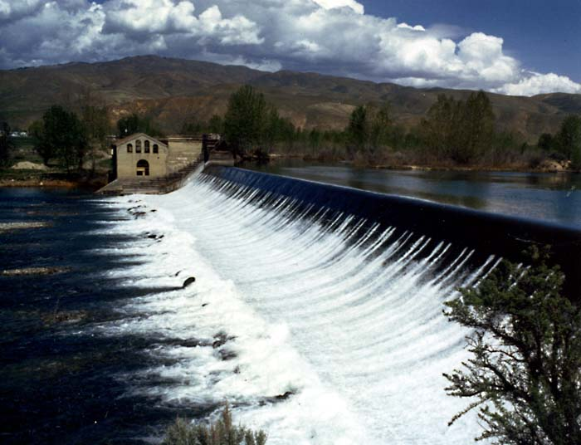

# Landfill Gas to Energy Project (lfgte)

**Overview**

Harnessing the power of landfill gas (LFG) energy provides environmental and economic benefits to landfills, energy users, and Ada County. LFG energy projects:

* 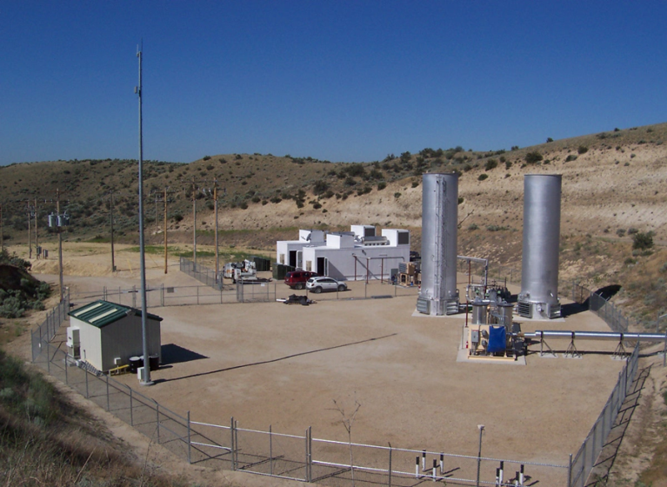Reduce greenhouse gases emissions
* Offset the use of non-renewable resources, such as coal, oil, and natural gas
* Improve local air quality
* Provide revenue for Ada County

**What is LFG?**

LFG is a natural byproduct of the decomposition of organic material in municipal solid waste (MSW) in anaerobic conditions. LFG contains roughly 50% methane and 50% carbon dioxide and trace amounts of inorganic and other compounds. When waste is first deposited in a landfill, it undergoes an aerobic (i.e., with oxygen) decomposition stage during which little methane is generated. Then, typically within less than one year, anaerobic (i.e., without oxygen) conditions are established and methane-producing bacteria decompose the waste and produce methane and carbon dioxide. Methane is a potent greenhouse gas (i.e., heat trapping) – over 20 times more potent than carbon dioxide, the primary cause of global warming. Landfills are the 2nd largest human-caused source of methane in the United States. This is why LFG must either be burned via flare or controlled combustion as heat input to produce electricity.

**Benefits to Ada County**

The 3.2 MW LFGTE system at the Hidden Hollow Landfill consists of two 1600 KW Caterpillar reciprocating engines generating approximately 2,100 MWhs per month which is sold directly to Idaho Power.

**Annual Energy Production and Revenue**

|  |  |  |  |  |
| --- | --- | --- | --- | --- |
|  | **kWh** | **Gas** | **Green Tags** | **Total** |
| 2007 | 18,364,800 | $157,871.82 | $34,888.56 | **$266,147.58** |
| 2008 | 21,435,206 | $192,380.91 | $49,388.60 | **$294,731.74** |
| 2009 | 21,370,914 | $194,734.04 | $49,119.17 | **$243,853.21** |
| 2010 | 23,093,621 | $215,267.77 | $60,021.95 | **$275,289.72** |
| 2011 | 23,683,902 | $225,865.82 | $60,787.84 | **$286,653.67** |
| 2012 | 21,722,451 | $211,937.67 | $56,470.07 | **$268,407.74** |
| 2013 | 20,278,871 | $202,410.26 | $52,708.08 | **$255,118.34** |
| 2014 | 18,242,849 | $186,309.66 | $47,414.48 | **$230,990.59** |
| 2015 | 21,167,580 | $221,138.37 | $5,671.37 | **$226,809.74** |
| 2016 | 22,049,502 | $235,686.30 | $12,158.61 | **$247,844.91** |
| 2017 | 20,609,154 | $225,355.30 | $9,022.76 | **$234,378.07** |
| 2018 | 21,897,736 | $244,952.73 | $16,602.77 | **$261,555.49** |
| 2019 (projected) | 25,363,538 | $290,246.22 | $28,404.36 | **$318,650.59** |

**GRAND TOTAL $3,410,431.39**

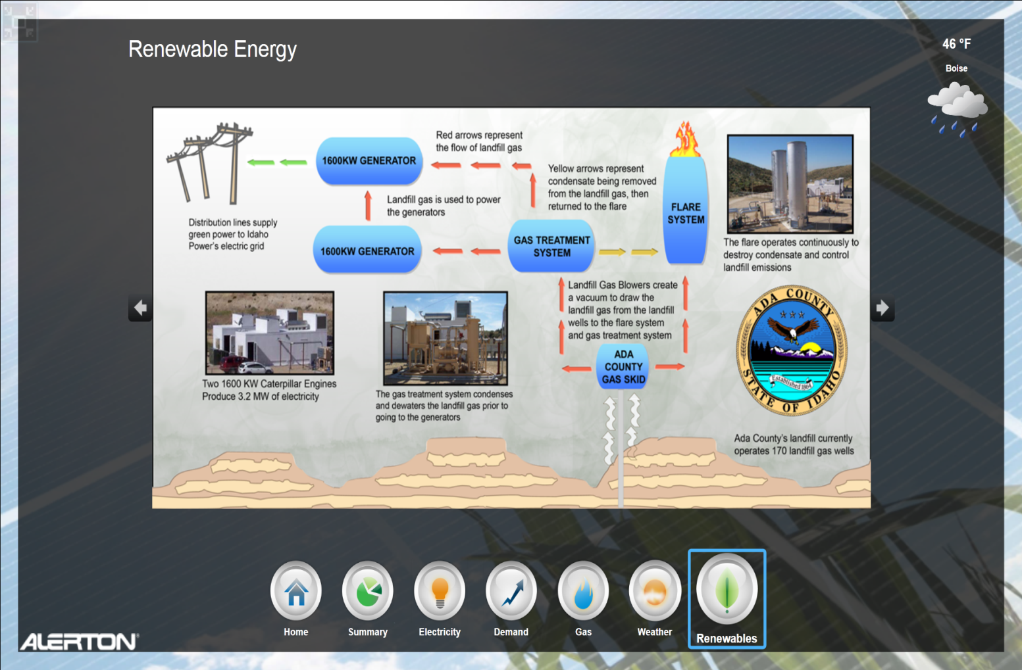

**transportation and fuel Goals**

Lessen the County’s overall contribution of GHG emissions and impact on traffic congestion by supporting programs and infrastructure that facilitate active transportation, multimodal options, fuel efficiency, trip reduction, the use of public transportation, and carpooling for County employees.

OBJECTIVES

* Decrease emissions and fuel consumption from county-owned vehicles, reduce waste and environmental impact
* Promote development of infrastructure for use of alternative fuels
* Promote alternative transportation use among county employees
* Support the Parks and Waterways Department in maintaining bike paths and trails within the county

TASKS TO SUPPORT OBJECTIVES

* Develop and implement standards for best practices in sustainable fleet maintenance and service
* Maintain “No Idling” policy at the Landfill to reduce emissions and fuel use
* Implement environmentally preferable purchasing (EPP) policy for vehicles
* Establish policy that 50% of new vehicles purchased for the County fleet will be hybrid or flex fuel vehicles
* Make waste cooking oil from Jail and Expo kitchens available for biodiesel
* Provide information about options for flex fuel and hybrid vehicles
* Participate in the Treasure Valley Clean Cities Coalition
* Report annually to Department of Energy the quantity and type of alternative fuel vehicles in the County fleet, miles traveled per year, fuel type, and alternative transportation mileage for County employees
* Evaluate options to increase use of ethanol-blended fuel
* Manage alternative transportation program
* Track employee incentives for vanpool riders
* Oversee County’s free bus service program for employees and quantify usage
* Install bike racks and repair stations at County facilities
* Promote May in Motion to stimulate regular ridership among employees
* Work with the Parks and Waterways Department to secure funding for improvements and ongoing maintenance of the existing trail system
* Provide resources such as construction management for trail repairs and improvement projects

## Employee Transportation and Parking Program

Ada County partners with the Ada County Highway District, Valley Regional Transit, and others to bring employees some great alternatives to driving to work. While employee parking is available at all County facilities, Ada County also provides easy, affordable alternative transportation options to reduce the need for parking and reduce commuter traffic, while improving air quality in Ada County.

**Bicycles**

Bike racks are located at all Ada County facilities for public and employee use. Free, secured bike storage is available to employees in the Civic Plaza parking garage, east of the Courthouse in downtown Boise.  Shower facilities are provided in some County locations for employees who walk or bicycle to work. Contact the Operations Department for locations and access codes. **Green Bikes:** The [Boise GreenBike](https://widget.socialbicycles.com/32/298) system is available to Ada County employees with a free annual membership ($70 value).

**Bus Passes**

All regular Ada County employees can ride the bus for FREE using their employee id card, including employees who commute between Ada and Canyon counties. Just hop on and present your id card!

**Commuteride Vanpools**

Commuteride is a local vanpool program run by the Ada County Highway District. Ada County employees are eligible for a free 1-month trial. New regular riders then receive a $20 transi-check for months 2-4 (provided by ACHD) plus a $32 voucher (provided each month by Ada County BOCC) which are applied toward the monthly fare. The rider pays any remaining amount. Fees vary depending on routes. Checks and vouchers are distributed each month by the Operations Dept. Contact for more details.

**Guaranteed Ride Home**

BE SURE TO SIGN UP FOR THE GUARANTEED RIDE HOME PROGRAM IF YOU REGULARLY USE ALTERNATIVE TRANSPORTATION. Commuters in carpools, vanpools, buses - even cyclists and walkers - are eligible for reimbursement for a taxi ride home for emergencies or overtime situations. The participant must be registered with Commuteride prior to the taxi ride and must have arrived to work using one of the modes listed above. An annual maximum benefit per participant is six taxi rides or a total cost of $300.00. This program is funded by ACHD.

**Parking - Downtown**

Limited free or metered parking is available downtown near the Courthouse on a first-come, first-served basis. Employees may purchase a parking space in a surface lot or in the parking garage. Free monthly parking is available downtown for employees who carpool with at least 1 other County employee. Drivers must share a single keycard, but there is no fee for the card. Vanpools and vanpool drivers are also eligible for free, preferred parking.

**County Fleet**

The County owns over 550 vehicles for use by employees, with 251 assigned to the Sheriff’s Office. The County operates two fuel islands and several vehicle shops to support its fleet. Replacing old vehicles allows the County to reduce fuel costs through increased efficiency and alternative fuel choices. As of 2019, 29% of the County’s vehicles were either hybrid or flex fuel (able to run on 85% ethanol fuel) although the County does not dispense 85% ethanol at its fuel islands.

**Procurement, Recycling, & Waste Goals**

Enhance the sustainability of the products entering County Operations, work towards minimizing the volume of purchases and incoming resources, and empower staff to make informed and responsible purchasing decisions. Reduce County-wide waste by implementing comprehensive reduce, reuse and recycling practices. Protect the environment through the proper disposal of waste.

OBJECTIVES

* Coordinate with procurement department to adopt environmentally preferable purchasing (EPP) practices
* Assist Information Technology in developing best management practices (BMP)’s for equipment purchases
* Increase recycling rates and promote waste reduction in County operations
* Improve and expand options for recycling at the Landfill

TASKS TO SUPPORT OBJECTIVES

* Explore implementation of green procurement standards and certifications
* Develop sustainable procurement plans for all County operations where practicable that reflect the highest feasible efficiency and lowest life cycle costs
* Purchase products made with recycled material when practical and feasible
* Consider efficiency in the cost analysis equation when making purchasing decisions
* Provide and encourage the use of non-disposable wares in breakrooms
* Incorporate PC purchasing standards into overall County EPP program
* Reuse and recycle PCs and other electronics
* Establish and support recycling programs for all County-owned facilities
* Develop incentives and campaigns to increase employee involvement in recycling
* Adopt paper reduction policies such as double-sided printing , electronic records management, and paperless workflow strategies
* Use shredding service in place of paper shredders to reduce everyday office waste and increase paper recycling
* Use secure shredding service when purging large volumes of County records, ensuring material is recycled and conserving landfill space
* Support and foster partnerships with local material reuse programs
* Support wood recycling program
* Maintain on-site recycling stations
* Provide roll-off bins for self-sorting of recyclable material
* Develop construction waste recycling program
* Facilitate recycling of gypsum for LEED projects within the County
* Continue incentives to Contractors who source separate material

**Outreach & Education Goals**

Clearly communicate goals, progress, and campaigns to stakeholders and participants by providing valid and accurate information and resources to achieve success. Engage employees in sustainability activities and foster a spirit of teamwork and innovation and progress.

OBJECTIVES

* Promote sustainability internally to Ada County employees throughout all departments
* Create a Best Practices Plan for cleaning services, landscaping crew, and building occupants on resource use and energy conservation and share with stakeholders
* Proactively promote public image and community involvement externally to Ada County residents
* Foster peer exchange through meetings with other counties, building owners, maintenance staff, etc. to share ideas

TASKS TO SUPPORT OBJECTIVES

* Develop a program and master plan for a Sustainability Education Program
* Implement communication and education campaigns to promote and report on the County’s sustainability activities and best practices
* Increase employee engagement and involvement in conserving energy and natural resources
* Mentor other organizations and departments to develop sustainability plans and metric
* Create a forum for conversation and idea development among staff
* Train custodial and management staff on best green practices
* Educate building occupants about basic building systems, energy efficient operations, and sustainable principles
* Identify and promote green office practices
* Explore implementing Integrative Pest Management and other green landscaping practices to minimize the introduction of harmful chemicals
* Implement multimedia marketing/PR program for Ada County’s Strategic Plan for SORC to Ada County residents
* Keep County website updated with current information about projects and facilities
* Expand sustainability information on the website and social media
* Establish channels for communication with the public
* Use Energy Awareness Month, Pollution Prevention Week, Earth Day, America Recycles Day, and other events to promote awareness of SORC
* Provide green building tours to individuals and groups as requested
* Collaborate with and support the work of outside organizations and agencies’ sustainability programs and efforts

# Facility Awards and Recognition

Ada County seeks opportunities to raise public awareness about its energy efficient operations and high performance facilities through various awards and certification programs.

## ENERGY STAR

ENERGY STAR is a voluntary U.S. Environmental Protection Agency (EPA) program that delivers environmental benefits and financial value through superior energy efficiency. By certifying top-performing products, homes, and buildings, ENERGY STAR helps us all make energy-efficient choices. It’s best known as the little blue mark on consumer products. Since 1992, EPA has also worked with businesses and public-sector organizations to transform the way that commercial buildings and industrial plants use energy. On average, ENERGY STAR certified buildings use 35 percent less energy and cause 35 percent fewer greenhouse gas emissions than similar buildings.

EPA offers the ENERGY STAR score for more than 30 different types of buildings and plants. It enables you to compare your facility’s actual energy performance to similar facilities nationwide. A score of 50 represents typical performance, while a score of 75 indicates that your facility performs better than 75 percent of all similar facilities nationwide and earns the ENERGY STAR plaque.

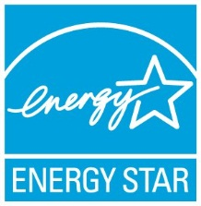

2004 Courthouse & Administration Building 76

2005 Courthouse & Administration Building 75

2006-2008 Courthouse & Administration Building 82

2009-2010 Courthouse & Administration Building 81

2011 Courthouse & Administration Building 84

2012 Courthouse & Administration Building 82

2013 Benjamin Building 77

2014 Courthouse & Administration Building 75

2015 Benjamin Building 78

2016 Courthouse & Administration Building 79

2017 Benjamin Building 80

2019 Courthouse Building 75

## LEED® Certifications

As a member of the US Green Building Council since 2003, Ada County uses the Leadership in Energy and Efficiency Design (LEED) program to ensure we build green, high performance buildings. Ada County has the distinction of earning the first LEED certification for any building in Idaho with the Ada County Courthouse.

 2005 Courthouse & Administration Bldg LEED-EB Silver

2006 Development Services Remodel LEED-CI Certified

2006 Barber Park Headquarters LEED-NC Certified

2008 Weed, Pest, & Mosquito Abatement LEED-NC Silver

2008 Paramedics Station, Meridian LEED-NC Silver

2009 Civic Plaza Office Complex LEED-CI Gold

2010 Paramedics Station, Star LEED-NC Gold

2012 Paramedics Administration Bldg LEED-NC Silver

2015 Paramedics Station, Ridenbaugh, Medic 17 LEED-NC Silver

*EB - Existing Building, NC - New Construction, CI - Commercial Interior*

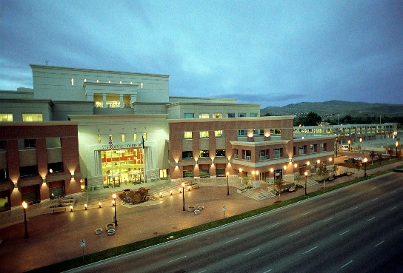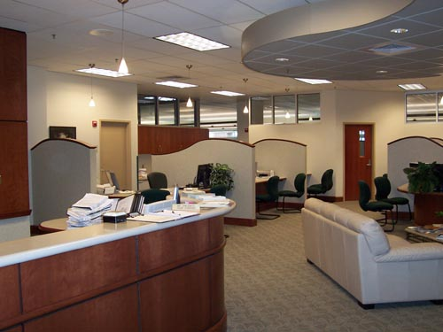

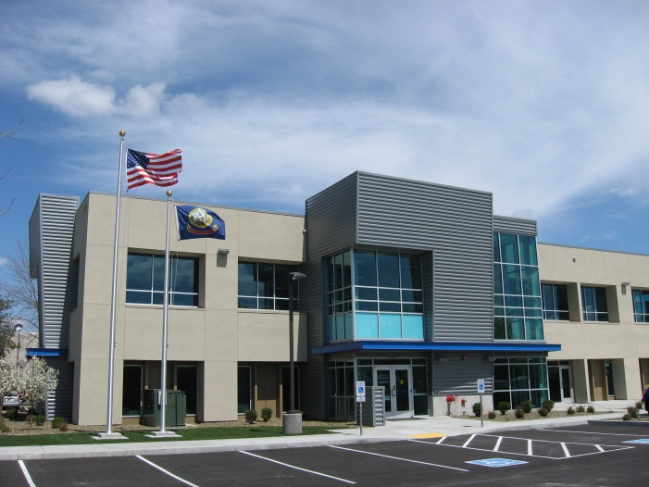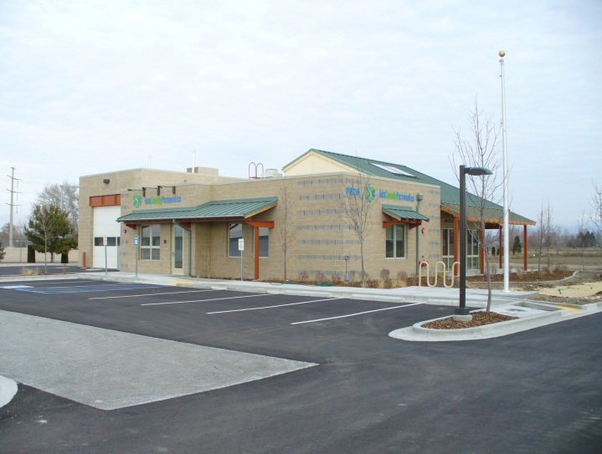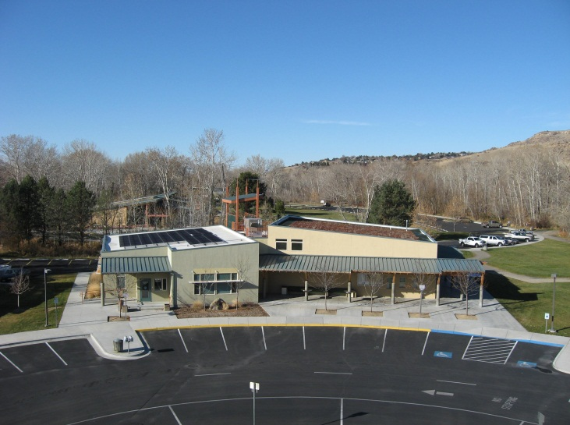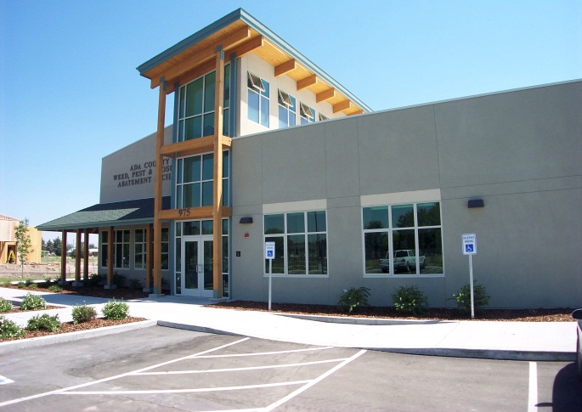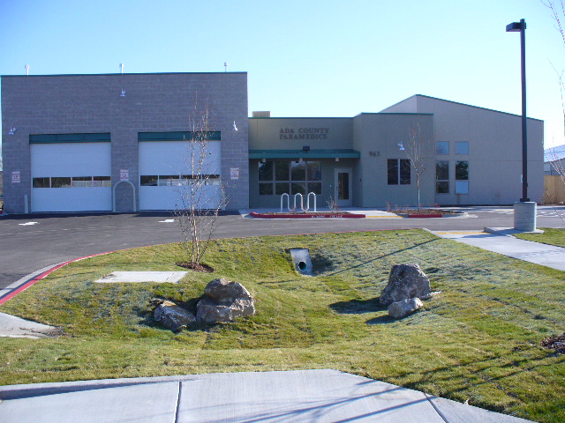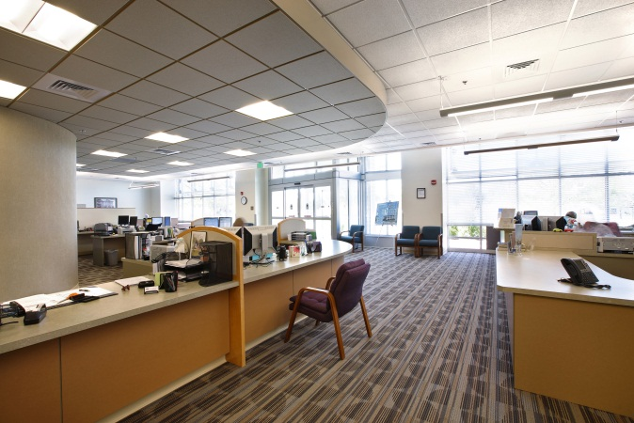

## LEED® Certified Building Projects

## May in Motion Alternative Transportation Awards

Ada County partners with the Ada County Highway District and Valley Regional Transit to provide employees with alternatives to driving to work. May in Motion is an annual event that allows organizations to become Alternative Transportation Champions and gain recognition for their employee participation and transportation benefits.

2007 Alternative Transportation Champion Award Bronze

2008 Alternative Transportation Champion Award Silver

2009 Alternative Transportation Champion Award Silver

2010 Alternative Transportation Champion Award Silver

2011 Alternative Transportation Champion Award Silver

2012 Alternative Transportation Champion Award Silver

2013 Alternative Transportation Champion Award Silver

2014 Alternative Transportation Champion Award Silver

2015 Alternative Transportation Champion Award Silver

2016 Alternative Transportation Champion Award Silver

2017 Alternative Transportation Champion Award Gold

2018 Alternative Transportation Champion Award Bronze

2019 Alternative Transportation Champion Award Silver

## Other Achievements

2004 EnviroGuard Award from the City of Boise

2008 Award of Citation in Architecture from The American Institute of Architects,

to McKibben+Cooper Architects for the Barber Park Administration and Raft Rental buildings

2008 Best Green Building Project in Idaho under $5 million from The Intermountain Contractors,

to CSHQA Architects for the Civic Plaza TI project

2010 ASHRAE High Performing Buildings Magazine, Summer edition, 10-page article on Courthouse

2012 NACO Energy Efficient County Buildings study

2014 Kilowatt Crackdown, Special Recognition Award: Most Dedicated – Benjamin Building

 2015 Ada County Named a Bronze Bicycle Friendly Business

by the League of American Bicyclists and formally

recognized the Ada County Courthouse as a

Bicycle Friendly Facility

2015 Idaho Business Review Top Projects Award:

Ada County Landfill Hydrogen Sulfide Scrubber, 2nd place Infrastructure/Transportation project category; all projects valued at $1 million+

Contacts

# Ada County Operations

## Scott Williams, Director, opwillis@adaweb.net

## Bruce Krisko, Deputy Director, [bkrisko@adaweb.net](mailto:bkrisko@adaweb.net)

## Selena O’Neal, Energy Specialist, [soneal@adaweb.net](mailto:soneal@adaweb.net)

## Phone: 208.287.7100

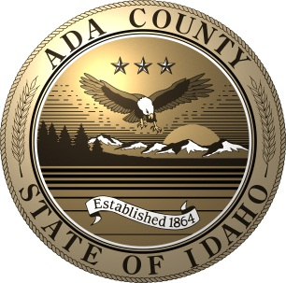

# 2019 Board of Ada County Commissioners

## Diana Lachiondo, District 1 Commissioner

## Rick Visser, District 2 Commissioner

## Kendra Kenyon, District 3 Commissioner & Chair

## Website: [www.adacounty.id.gov](http://www.adacounty.id.gov)

## Email: [bocc1@adaweb.net](mailto:bocc1@adaweb.net)

## Phone: 208.287.7000