ADA COUNTY HISTORIC PRESERVATION COUNCIL |  |  | 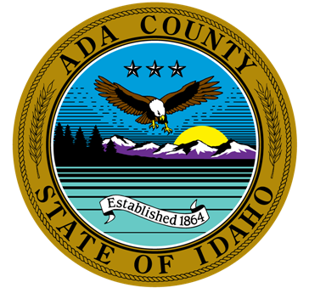
200 W. Front Street  Boise, Idaho 83702  P. (208) 287-7900  F. (208) 287-7909 | Frank Eld, Chair  Kathryn Almberg  Forrest Hunter | Robert Martinez, Vice-Chair  Dave Davies  Michael Oths |  | Ted Vanegas, Secretary  Paul Frise  Sarah Schafer
The purpose of the Ada County Historic Preservation Council is to promote the educational, cultural, economic and general welfare of the public of Ada County through the identification, evaluation, designation, and protection of those buildings, sites, areas, structures, and objects which reflect significant elements of the county’s, the state’s and the nation’s historic, architectural, archaeological, and cultural heritage.

AGENDA FOR MARCH 2, 2021, 12:00 P.M.

VIRTUAL MEETING

The meeting will be conducted via WebEx Video Conference. If you would like to participate by phone or video, please contact Brent Danielson. He can be reached at bdanielson@adacounty.id.gov or (208) 287-7913.

CALL TO ORDER

ROLL CALL & INTRODUCTION OF GUESTS
Members |  |  |  |  |  | Staff & Others
 | Frank Eld |  | Robert Martinez |  | Ted Vanegas |  | Brent Danielson, Staff
 | Kathryn Almberg |  | Dave Davies |  | Paul Frise |  | Brianna Bustos, Staff
 | Forrest Hunter |  | Michael Oths |  | Sarah Schafer |  | Mike Edwards, Ada County Parks Dept.

AGENDA ADDITIONS / CHANGES

APPROVAL OF MINUTES
- February Minutes

ACTION / INFORMATION / DISCUSSION ITEMS
- CLG Grant Update – Brent
- County Treasure Award Update – Brent
- Update on New Council Members - Brent
- Operational Plan for 2021 - Council
- Ada County Parks Department Update on Oregon Trail Recreation Area – Mike Edwards
- Follow-up on Demolition Permits - Brent
- Follow-up to Historic Preservation in Cities that are not a CLG - Council
- Written Articles Follow up – Council
- Follow-up Ideas for Idaho Archaeology and Historic Preservation Month (May) - Council
- Outreach to other Historic Groups within Ada County – Council
- Future Agenda Items – Council
- Farewell to Mike & Forrest - Council

UPCOMING EVENTS
March 4, 2021 | History Happy Hour: Idaho Day! 100 Years of the People’s House  Presentation on the 100th anniversary of the dedication of the Idaho State Capitol Building  Zoom, Pre-registration is required. https://zoom.us/webinar/register/8316123082179/WN_Wv5olXCOSuuZqyr5vuKFDg | 6:00 PM – 7:00 PM
March 13, 2021 | Family Second Saturday: Trailblazing Women of Idaho  Opening of Museum Exhibit that honor centuries of Idaho’s women, from artists and astronauts to adventurers and advocates.  Idaho State Museum. Pre-registration is required.  https://store.history.idaho.gov/PerformanceCalendarCamp.aspx?lid=-2&eid=103&month=3/1/2021%2012:00:00%20AM | 6:00 PM – 7:00 PM
April 1, 2021 | Fettucine Forum: Verse Serves, Writing Victoria Woodhull Back into History”  Diane Raptosh, author, poet, and professor at the College of Idaho, considers Victoria Claflin Woodhull, the first woman to address Congress and to run for U.S. President, with abolitionist Frederick Douglass as presumptive running mate.  Zoom, Pre-registration is required.  https://cityofboise.zoom.us/webinar/register/WN_i0zhtI7ARK-YAn7DW2fYYw | 6:00 PM – 7:00 PM

ADJOURNMENT
A. Next Scheduled Meeting: April 6, 2021

