ADA COUNTY HISTORIC PRESERVATION COUNCIL |  |  | 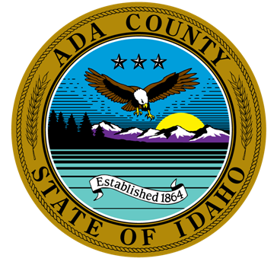
200 W. Front Street  Boise, Idaho 83702  P. (208) 287-7900  F. (208) 287-7909 | Frank Eld, Chair  Kathryn Almberg  Angela Hansen  Sarah Schafer | Robert Martinez, Vice-Chair  Dave Davies  Forrest Hunter |  | Ted Vanegas, Secretary  Paul Frise  Michael Oths
The purpose of the Ada County Historic Preservation Council is to promote the educational, cultural, economic and general welfare of the public of Ada County through the identification, evaluation, designation, and protection of those buildings, sites, areas, structures, and objects which reflect significant elements of the county’s, the state’s and the nation’s historic, architectural, archaeological, and cultural heritage.

AGENDA FOR FEBRUARY 2, 2021, 12:00 P.M.

VIRTUAL MEETING

The meeting will be conducted via WebEx Video Conference. If you would like to participate by phone or video, please contact Brent Danielson. He can be reached at bdanielson@adacounty.id.gov or (208) 287-7913.

CALL TO ORDER

ROLL CALL & INTRODUCTION OF GUESTS
Members |  |  |  |  |  | Staff & Others
 | Frank Eld |  | Robert Martinez |  | Ted Vanegas |  | Brent Danielson, Staff
 | Kathryn Almberg |  | Dave Davies |  | Paul Frise |  | Brianna Bustos, Staff
 | Angela Hansen |  | Forrest Hunter |  | Michael Oths |  | Mike Edwards, Ada County Parks Dept.
 | Sarah Schafer

AGENDA ADDITIONS / CHANGES

APPROVAL OF MINUTES
- January Minutes

ACTION / INFORMATION / DISCUSSION ITEMS
- CLG Grant Update – Brent
- County Treasure Award Update - Brent
- Ada County Parks Department Update on Oregon Trail Recreation Area – Mike Edwards
- Historic Preservation in Cities that are not a CLG Discussion - Council
- Operational Plan for 2021 – Council
- Written Articles – Council
- Ideas for Idaho Archaeology and Historic Preservation Month (May) - Council
- Outreach to other Historic Groups within Ada County – Council
- Future Agenda Items - Council

UPCOMING EVENTS
February 3, 2021 | History Happy Hour: Idaho Ebony  Zoom, Pre-registration is required. | 6:00 PM – 7:00 PM
February 4, 2021 | Fettucine Forum: “See Idaho First”  Online, Pre-registration is required | 6:00 PM – 7:00 PM

ADJOURNMENT
A. Next Scheduled Meeting: March 2, 2021

