ADA COUNTY HISTORIC PRESERVATION COUNCIL |  |  | 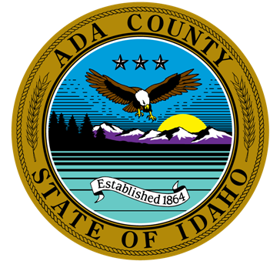
200 W. Front Street  Boise, Idaho 83702  P. (208) 287-7900  F. (208) 287-7909 | Ted Vanegas, Chair  Kathryn Almberg  Paul Frise  Robert Martinez | Michael Oths, Vice-Chair  Dave Davies  Angela Hansen |  | Sarah Schafer, Secretary  Frank Eld  Forrest Hunter
The purpose of the Ada County Historic Preservation Council is to promote the educational, cultural, economic and general welfare of the public of Ada County through the identification, evaluation, designation, and protection of those buildings, sites, areas, structures, and objects which reflect significant elements of the county’s, the state’s and the nation’s historic, architectural, archaeological, and cultural heritage.

AGENDA FOR TUESDAY MAY 5, 12:00 P.M.

VIRTUAL MEETING

The meeting will be conducted via WebEx Video Conference. If you would like to participate by phone or video, please contact Brent Danielson. He can be reached at bdanielson@adacounty.id.gov or (208) 287-7913.

CALL TO ORDER

ROLL CALL & INTRODUCTION OF GUESTS
Members |  |  |  |  |  | Staff & Others
 | Ted Vanegas |  | Michael Oths |  | Sarah Schafer |  | Brent Danielson, Staff
 | Kathryn Almberg |  | Dave Davies |  | Frank Eld |  | Brianna Bustos, Staff
 | Paul Frise |  | Angela Hansen |  | Forrest Hunter |  | Mike Edwards, Ada County Parks Dept.
 | Robert Martinez

AGENDA ADDITIONS / CHANGES

APPROVAL OF MINUTES
- March Minutes

ACTION / INFORMATION / DISCUSSION ITEMS
- 2019 CLG Grant Project Update – Brent
- Demolition Ordinance Update - Brent
- Operational Plan for 2020 – Council
- Making History Award - Council
- Ada County Parks Department Update on Oregon Trail Recreation Area – Mike Edwards
- 2020 Community Enhancement Grant – Council
- Outreach to other Historic Groups within Ada County – Council
- Future Agenda Items - Council

UPCOMING EVENTS
May 16, 2020 | Walk About Boise Tour  Bench in front of Basque Museum, Grove Street, $12 | 11:00 AM – 12:30 PM
May 23, 2020 | Walk About Boise Tour  Bench in front of Basque Museum, Grove Street, $12 | 11:00 AM – 12:30 PM
May 30, 2020 | Walk About Boise Tour  Bench in front of Basque Museum, Grove Street, $12 | 11:00 AM – 12:30 PM

ADJOURNMENT
A. Next Scheduled Meeting: June 2, 2020

