ADA COUNTY/ ADA COUNTY AMBULANCE DISTRICT (EMS)

DEVELOPMENT IMPACT FEE ADVISORY COMMITTEE

200 W. Front Street  Boise, Idaho 83702  P. (208) 287-7900  F. (208) 287-7909 | Wes Jost - Chair  Pete Schindele  Natalie MacLachlin | Nicolette Kimmel - Vice Chair  David Yorgason  Chris Findlay
The purpose of the Ada County/EMS Development Impact Fee Advisory Committee is to assist the Board of Ada County Commissioners in the adoption, implementation and updates to the Ada County Development Impact Fee Study and Capital Improvement Plan. The Committee also make recommendations on how the funds collected from development impact fees should be used and when assumptions or studies need to be updated.
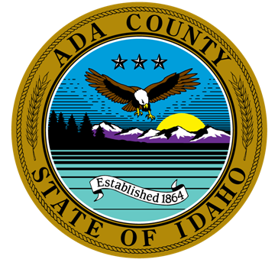

MINUTES FOR MARCH 30, 2023, 4:00 P.M.

VIRTUAL Or in PERSON MEETING

The meeting will be conducted at 200 W Front Street, Development Services Office and/or via WebEx Video Conference. If you would like to participate by phone or video, please contact Leon Letson. He can be reached at lletson@adacounty.id.org or (208) 287-7950.

CALL TO ORDER –

ROLL CALL & INTRODUCTION OF GUESTS
Members |  |  |  | Guests |  | Staff
X | Wes Jost | X | David Yorgason | X | Colin McAweeney | X | Leon Letson, Staff
X | Nicolette Kimmel | X | Chris Findlay | X | Eagle Fire District |  | Brianna Bustos, Staff
X | Pete Schindele
X | Natalie MacLachlin

AGENDA ADDITIONS / CHANGES

NEW BUSINESS:
  - Review/Recommendation of NACFR and Eagle Fire District CIP/Fees.
Colin McAweeney from TischlerBise presented the NACFR and Eagle Fire District CIP/Fees. The DIFAC requested additional time to review these materials and provide comment. Questions/concerns were raised around the growth projections, particularly as it relates to the split of single-family, multi-family, and commercial square footage growth in various communities (i.e. Garden City and Hidden Springs), as well as the cost/type of facilities included in the NACFR CIP. David Yorgason moved to table these items for a follow up meeting. Chris Findlay seconded. Approved 5-0.

APPROVAL OF MINUTES:
  - November 17, 2022 meeting minutes
David Yorgason moved to approve the November 17, 2022 minutes. Chris Findlay seconded. Approved 5-0.

ADJOURNMENT –
- Next Scheduled Meeting: June 22, 2023 (third Thursday of the month), 4:00 p.m.
The Committee requested to schedule a meeting within a month to further review and provide comment on the NACFR and Eagle Fire District CIP/Fees. Meeting adjourned at 5:10 p.m.

