ADA COUNTY/ ADA COUNTY AMBULANCE DISTRICT (EMS)

DEVELOPMENT IMPACT FEE ADVISORY COMMITTEE

200 W. Front Street  Boise, Idaho 83702  P. (208) 287-7900  F. (208) 287-7909 | Chris Findlay - Chair  Natalie MacLachlin  David Yorgason  (Open Seat) | Nicolette Kimmel - Vice Chair  Gordon Trounson  (Open Seat)
The purpose of the Ada County/EMS Development Impact Fee Advisory Committee is to assist the Board of Ada County Commissioners in the adoption, implementation and updates to the Ada County Development Impact Fee Study and Capital Improvement Plan. The Committee also make recommendations on how the funds collected from development impact fees should be used and when assumptions or studies need to be updated.
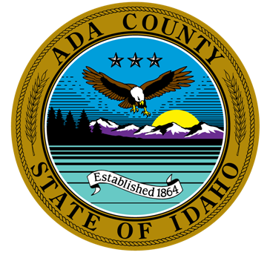

MINUTES for October 26, 2023, 4:00 P.M.

VIRTUAL Or in PERSON MEETING

The meeting will be conducted at 200 W Front Street, Development Services Office and/or via WebEx Video Conference. If you would like to participate by phone or video, please contact Leon Letson. He can be reached at lletson@adacounty.id.org or (208) 287-7950.

CALL TO ORDER –

ROLL CALL & INTRODUCTION OF GUESTS
Members |  |  |  | Guests |  | Staff
X | Nicolette Kimmel |  | Gordon Trounson | X | Colin McAweeney | X | Leon Letson, Staff
X | Natalie MacLachlin |  |  |  | Shelly Buchanan |  | Brianna Bustos, Staff
X | David Yorgason
X | Chris Findlay

AGENDA ADDITIONS / CHANGES

NEW BUSINESS:

UNFINISHED BUSINESS:
- Review Updated Ada County Development Impact Fees
Colin McAweeney from TischlerBise provided an overview of the updated Impact Fee Studies for Ada County, specifically addressing questions related to growth projections in Ada County. Additional discussion focused on how Ada County plans to account for new station construction and meeting current level of service standards, vs. introducing a new level of service standard (i.e. different finishes, amenities, etc. within new stations), as well as how development impact fees would interplay with the bond for the Jail, if approved. Dave Yorgason moved to approve this item. Natalie MacLachlin seconded. Approved 4-0.

- Review Updated Star Fire District Development Impact Fees
Colin McAweeney from TischlerBise provided an overview of the updated Impact Fee Studies for Star Fire District. Discussion focused on concerns from the home building industry regarding how these fees are growing. Nicolette Kimmel moved to approve this item on the condition the City of Star also approved. Dave Yorgason seconded. Approved 4-0.

- Review of Updated Melba Fire District Development Impact Fees
Colin McAweeney from TischlerBise provided an overview of the updated Impact Fee Studies for Melba Fire District. Discussion focused on the fact that less than 10% of the projected impact fee revenue to be collected will occur in Ada County, vs. Canyon County. Dave Yorgason moved to approve this item on the condition the City of Melba also approved. Nicolette Kimmel seconded. Approved 4-0.

APPROVAL OF MINUTES:
- September 28, 2023 meeting minutes
Dave Yorgason moved to approve this item. Natalie MacLachlin seconded. Approved 4-0.

ADJOURNMENT –
- Next Scheduled Meeting: December 28, 2023 (fourth Thursday of the month), 4:00 p.m.

