ADA COUNTY/ ADA COUNTY AMBULANCE DISTRICT (EMS)

DEVELOPMENT IMPACT FEE ADVISORY COMMITTEE

200 W. Front Street  Boise, Idaho 83702  P. (208) 287-7900  F. (208) 287-7909 | Wes Jost - Chair  Pete Schindele  Natalie MacLachlin | Nicolette Kimmel - Vice Chair  David Yorgason  Chris Findlay
The purpose of the Ada County/EMS Development Impact Fee Advisory Committee is to assist the Board of Ada County Commissioners in the adoption, implementation and updates to the Ada County Development Impact Fee Study and Capital Improvement Plan. The Committee also make recommendations on how the funds collected from development impact fees should be used and when assumptions or studies need to be updated.
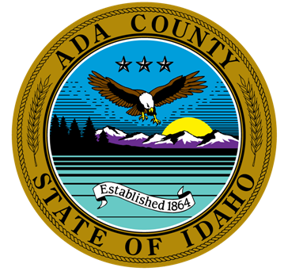

AGENDA FOR NOVEMBER 17, 2022, 4:00 P.M.

VIRTUAL Or in PERSON MEETING

The meeting will be conducted at 200 W Front Street, Development Services Office and/or via WebEx Video Conference. If you would like to participate by phone or video, please contact Leon Letson. He can be reached at lletson@adacounty.id.org or (208) 287-7950.

CALL TO ORDER –

ROLL CALL & INTRODUCTION OF GUESTS
Members |  |  |  | Guests |  | Staff
x | Wes Jost | x | David Yorgason | x | Anne Wescott | x | Leon Letson, Staff
x | Nicolette Kimmel | x | Chris Findlay |  |  |  | Brianna Bustos, Staff
 | Pete Schindele |  |  |  |  |  | Brent Moore, Staff
 | Natalie MacLachlin

AGENDA ADDITIONS / CHANGES

NEW BUSINESS:
  - Review/Recommendation of Kuna Fire District CIP/Fees.

Anne Wescott briefed the Committee on updates to the Kuna Fire District CIP and associated development impact fees. Chris Findlay moved to recommend adoption of the updates. Nicolette Kimmel seconded: Approved 4-0.

  - Discussion of Forthcoming CIP/Fees from other Fire Districts.

Anne Wescott briefed the Committee on forthcoming updates to CIPs and
development impact fees from other Fire Districts in Ada County. These CIPs and fees will be reviewed in more depth by the Committee at a later date. No decision
required.

APPROVAL OF MINUTES:
  - July 7, 2022 meeting minutes

Chris Findlay moved to approve the July 2, 2022 minutes. David Yorgason seconded;
Approved 4-0.

ADJOURNMENT –
- Next Scheduled Meeting: February 16, 2022 (third Thursday of the month), 4:00 p.m.

