How to File for Guardianship of a Minor Child in Ada County

These forms are for Guardianship of a Minor Child when both parents agree to the Guardianship. If a parent does not agree, you should talk to an attorney.
Get court forms: (The name of the court form is found at the bottom of each form.)
To Start the Case
- Family Law Case Information Sheet for De Facto Custodian, Adoption and Minor Guardianship Cases
- Petition for Appointment of Guardian of a Minor
- Notice of Guardianship Petition and Hearing
- Acceptance of Appointment by Guardian
- Consent to Appointment of Guardian
- Waiver of Notice (optional)
- Nomination by Minor (if child is 14 or older)

To Finalize General Guardianship
- Order Re Appointment of Attorney or Guardian ad Litem
- Judgment Appointing Guardian of Minor
- Letters of Guardianship
- Affidavit of Service
For Temporary Guardianship
File all forms listed above and the following:
- Order Appointing Temporary Guardian
- Letter of Temporary Guardianship
- Notice of Temporary Guardianship
Get these
court forms for FREE at
www.courtselfhelp.idaho.gov

Fill out heading on all court forms:
Using black ink, fill out the heading on all forms with your information, see the following example. (Ask the court if you do not know your district and county information.)
Ada County CAO GCM Instruction 1-1 05/06/2021
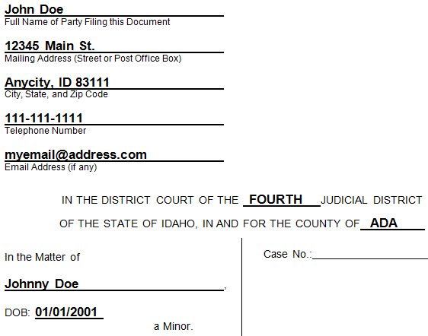
SAMPLE FORM
Fill out and sign court forms:
Form 1. Family Law Case Information Sheet for De Facto Custodian, Adoption and Minor Guardianship Cases: Fill out the form as completely as possible with the information requested. This form will be kept confidential.
Form 2. Petition for Appointment of Guardian of a Minor: You are the Petitioner. Fill out Pages 1-4 completely and sign and date where shown.
Form 3. Notice of Guardianship Petition and Hearing: Sign and date. Leave the hearing date blank unless you have been given a court date by the clerk.
On page 2, fill out information for all persons that require notice. Notice must be given to the minor child if he/she is at least 14 years old, any person who has had principal care and custody of the child during the 60 days prior to the date of the petition, and any living parent of the child. Print your name and sign at the bottom.
Form 4. Acceptance of Appointment by Guardian: Sign and date to show you want to be appointed as guardian and accept the responsibilities of guardian.
Need signatures from minor’s parents:
Form 5. Consent to Appointment of Guardian: Parents can sign this form to show they agree to the guardianship. The parent should check the appropriate boxes then sign and date the form. Each living parent must complete a separate form.
Form 6. Waiver of Notice: Any living parent or a person who has had principal care and custody of the minor during the 60 days prior to the petition can choose not to receive notice of the guardianship process and all court documents. They can waive their right to receive notice and documents by signing this form.
Have the minor sign, (if age 14 or older):
Form 7. Nomination by Minor: If the child is 14 or older, the child must sign and date the form.
Complete the Forms the Judge will sign:
Fill out the heading of the following forms, but do not sign these forms:
- Order Re Appointment of Attorney or Guardian ad Litem
- Judgment Appointing Guardian of Minor
- Letters of Guardianship.
If you have requested temporary guardianship also fill out the heading on these forms:
- Order Appointing Temporary Guardian
- Letter of Temporary Guardianship
- Notice of Temporary Guardianship.
Note: This Notice must be sent to all interested persons within 72 hours of the appointment of a temporary guardian.
Make copies of court forms:
Make copies of the Petition for Appointment of Guardian of a Minor, Acceptance of Appointment by Guardian, and any signed forms listed in Steps 4 and 5. You will need a copy for your records and a copy for anyone else who must also receive notice.
Talk to an attorney. These instructions are not a substitute for legal advice. The laws and court rules are complex and following these instructions will not guarantee you a favorable result. We always recommend you talk with an attorney before filing paperwork.

File the guardianship
Take the original and all copies to the courthouse or set up an e-filing account. Pay the filing fee of $216, and pre-pay $25 for a guardian training. If you cannot afford those fees, you can fill out a Motion and Affidavit for Fee Waiver.
Attend the guardian training:
Once you pay the $25 guardian training fee, or your fees are waived, the court issues an Order to Complete Training with program access information. Complete the training and file the Certificate(s) of Completion with the court. A hearing on your petition will not be set until the Certificate(s) is/are filed.
Get a hearing date for your Petition:
After you have attended the guardian training, filed your Certificate(s) of Completion, and the judge has signed the Order Re: Appointment of Attorney or Guardian ad Litem, call the courthouse at (208)287-6900 to request a hearing date.
Serve notice:
Personally deliver OR mail by certified, registered or ordinary first class mail a copy of your court forms at least 14 days before the hearing date to all persons that require notice. Fill out and sign the Affidavit of Service, then take it to the courthouse.
*You do not need to serve notice on a person if they signed the Waiver of Notice.
FINAL STEP: Attend the court hearing:
At the court hearing, the judge will call the case name and case number. You should step forward and answer any questions that the judge may have for you. The judge will tell you if the guardianship was granted, and if so, sign the order.
ONGOING REPORTING REQUIREMENTS
Once a guardianship is granted the Guardian will be responsible for providing the court with reports on a yearly basis. Visit the Court Assistance website for those forms at: www.courtselfhelp.idaho.gov .

