How to Sue in Small Claims Court
Small Claims Court is a special court where:
- A person or a business can sue for up to $5,000. (You can sue for more than $5,000,
but you must sue in Magistrate Court. You cannot get around the $5,000 limit by filing 2 small claims.)
- The rules are simple.
- You don’t need a lawyer. (You can talk to a lawyer before and after your trial, but you cannot have a lawyer speak for you in court. If you are a business, the owner or an employee can speak in court, as long as the employee is not a lawyer.)

To Start Your Case…
Fill out these court forms:
- Claim form (You are the Plaintiff. The person or business you are suing is the Defendant.)
- Summons
- Affidavit of Competence and Non-Military Service (Ada County)
You can get these forms from the Court Clerk or online to print or e-file them:
Guide & File and E-file: To use an online interview to prepare your forms or to e-file go online to: http://guideandfile.idaho.gov.
If you are a business filing the claim in a county where e-filing is available, you must e-file your documents.
Print: To print and fill out your forms go to: www.courtselfhelp.idaho.gov/small-claims. Sign and date the completed forms. Make at least two copies: 1 for you and 1 for each Defendant.
Take your completed forms to a court in the county where the Defendant lives or the problem happened.

There is a $69 filing fee for Small Claims cases.
Different kinds of cases have different deadlines. If you miss your deadline, you won’t be able to file your claim. To know the deadline for your case, ask a lawyer or read this state law: http://legislature.idaho.gov/
statutesrules/idstat/Title5/T5CH2/
Someone – not you – serves the Defendant
Each Defendant must be served (given) a copy of the papers you file at court and additional forms. Read How to Serve Your Small Claims Papers to know what to do.
Warning! If you do not serve correctly, the court will close your case.
Wait 21 days for the Defendant to “answer”
If the Defendant files an Answer within 21 days of being served, that means s/he disagrees with your claim. If this happens, the Clerk will mail you:
A Notice with the date and time of your trial, and
A copy of the Defendant’s Answer, which explains his/her side of the case.
If the Defendant does not “answer” within 21 days (and was served correctly) you will get:
A Notice with the date and time of your trial, or
You can request a Default form to fill out and file. The Default requests that the court grant your claim because Defendant did not respond within the deadline.
A judge will review your claim and evidence. You will win your case if:
The judge decides your claim is valid,
You go to your trial (or file a complete Default).
The Defendant is 18 or older and able to understand what the case is about.
You show the court that the Defendant is not on active military duty. Contact the Defense Manpower Data Center for a free report:
Tel.: 1-800-538-9552
Online: https://scra.dmdc.osd.mil/scra/#/home (only if you have the Defendant’s social security number or date of birth).
Important: If the Defendant could not answer because s/he is in the U.S. Armed Forces, you may not be able to get a default judgment.
If you meet these requirements, the clerk will mail or give you a copy of the “default judgment.”
Contact the Clerk if…
You cannot go to your trial on the date listed on the Notice. If you have an urgent reason to change the date, file a Motion and Order to Continue at least 2 weeks before your trial.
You or a witness needs help with English or has hearing problems. The Clerk can send a free interpreter to your trial. The court does not allow friends or relatives to interpret for you.
How to Serve Your Small Claims Papers
The Defendant must be served (given) a copy of all the papers you file in Small Claims Court.
If there is more than one Defendant in your case, each one must be served separately – even if
they are married or living together.
After you serve the Defendant you must file an Affidavit of Service with the Court. In most cases the deadline to serve and file this Affidavit is 30 days. Some courts allow up to 90 days after you file your Claim. Ask the clerk about your deadline.
To serve the Defendant follow these steps:
Fill out the header in the Affidavit of Service form.
You can get the form from the Court Clerk or online at: courtselfhelp.idaho.gov/small-claims.
Have someone 18 or older – not you – serve the Defendant.
Each Defendant must be served (given) a copy of these forms: Summons, Small Claim, Answer (Blank), Instructions for Defendant. The Defendant can be served by mail or personal delivery.
- For U.S. Certified mail service
If you pay a fee, the Clerk can have the Defendant served by certified mail, return receipt.
Warning! If the Defendant refuses to sign the return receipt or if someone who is not the Defendant signs, you will have to serve the Defendant again, using personal service. If this happens, the Clerk will notify you.
- For personal service, choose 1 of these options:
- Pay the Sheriff’s office (or the Marshal’s office for some
counties) to serve the papers. You must tell them exactly
where to find the Defendant. The Sheriff or Marshal
will give you the Affidavit of Service.
In some counties, you pay the Court Clerk and the Sheriff or Marshal gives the Affidavit of Service to the Clerk. Ask the Clerk how it works in your county.
- Pay a professional process server. You must:
- Give the server a copy of your court forms.
- Explain exactly where to find the Defendant.
If you do not know where the Defendant can be found, some process servers will investigate for you, for a fee.
- Ask someone 18 or older – not you or anyone else involved in this case – to personally give each Defendant a copy of your court papers.
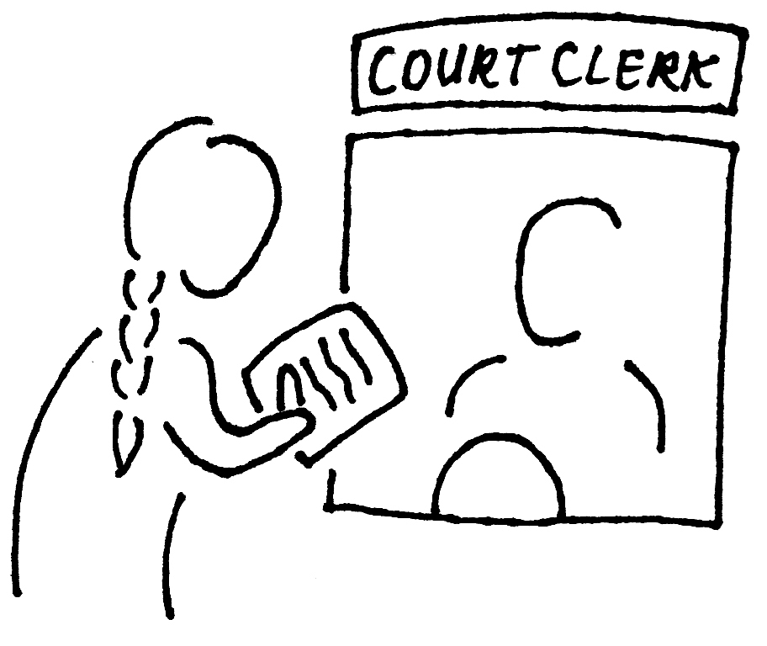
File the Affidavit of Service
After serving, ask the server to fill out the Affidavit of Service form and return it to you. Then you must file the Affidavit of Service with the Clerk, or you can file it at your trial.
If you miss your deadline to file the Affidavit of Service, or if you serve incorrectly, you can file your claim again if you are within the statute of limitations for your claim. If you file again within 6 months of filing your first claim, you may not have to pay another filing fee.
Get Ready for Your Small Claims Trial

Arrive early!
Look for the date and time of your trial on your Notice. You may need extra time to get through security and find your courtroom.
Check in with the Clerk.
In some counties, the court will order you and the other side to talk to a mediator. The mediator will try to help you settle the case without going to trial.
Bring your forms with you.
- Turn your phone off. Remove your hat. No food, no gum, no drinks in the courtroom.
- Stay calm. Be polite. Do not interrupt anyone.
- Do not speak until the judge asks you to.
- If you do not understand something, say, “I don’t understand.”
Tip: Do not bring children unless they can sit quietly for a few hours.
Wait for the court to call your case.
The judge will ask you to speak first. This is your chance to show why you should win. Say the most important reasons that support your case.
Tip: It’s OK to make notes about what you want to say. If you get nervous, just read from your notes.
Bring evidence.
Give the judge copies of your proof that supports your case, such as:
- Contracts or other documents
- Receipts or cancelled checks
- Invoices or statements
- Photos
Tip: If you have an audio, video, or other recording, talk to the Clerk as soon as possible. Ask if you need to bring your own equipment.
You can bring witnesses or statements.
You may have a witness speak at your trial. If it’s hard for the witness to go to court, ask the witness to write a statement.
If only an expert would know if your claim is correct, you may bring an expert witness (or their statement).
Listen while the Defendant explains his or her side of the case.
If the Defendant is at the trial, the Defendant may show evidence, bring witnesses or statements, and explain why you should not win your case.
After your trial, get your judgment.
The judge decides many cases at the end of the trial and gives you and the Defendant a copy of his/her decision (the judgment). If the judge decides later, you will get the judgment in the mail.
If you do not agree with the court’s decision, you can appeal (fight the court’s decision) if:
- You lose your case, or
- You win your case, but the court gives you less money than you asked for.
If you want to appeal, you have 30 days after the date of the judgment to file a Notice of Appeal with the Clerk. You will have to pay an $81 filing fee.
Warning! The 30-day deadline is very strict.
If the Defendant does not agree with the court’s decision, s/he can also appeal. If this happens, the Clerk will send you a Notice of Appeal.
Note: Appeals are more formal than small claims process. The parties can have lawyers.
If you win, collect your judgment.
If you win your case, the court will make a judgment and order the Defendant to pay you or return property to you.
If the Defendant does not pay, the court will not collect it for you. But there are things you can do to get your money/property. See the brochure from the Clerk or online: Collecting on Your Small Claims Judgment (Under Small Claims here: courtselfhelp.idaho.gov/publications)
After the Defendant pays, file a form.
You must tell the court when the Defendant has paid the total judgment by filing a Satisfaction of Judgment form. Get this form from the Clerk or online at: courtselfhelp.idaho.gov/small-claims
Warning! If you do not file this form, the court can order you to do it.
Questions?
- Visit the Court Assistance Office at your local county courthouse.
- Talk to a lawyer. The court cannot give legal advice.

