INSTRUCTIONS: HOW TO RENEW A CIVIL JUDGMENT

If you were awarded the judgment you are known as the judgment creditor. The person who was ordered to pay you is known as the judgment debtor. Your judgment will expire if your judgment has not been paid in full and you fail to renew it in time.

Determine the Expiration Date.
5 Year Expiration prior to July 1, 2015
A Judgment expires 5 years from the judgment date if it was entered prior to July 1, 2015, and can be renewed for 5-year periods.
10 Year Expiration July 1, 2015 and later
A Judgment expires 10 years from the date of judgment if it was entered on July 1, 2015 or later, and can be renewed for 10-year periods.
A Judgment for Child Support arrears can generally be renewed for 10 years regardless of when it was originally entered, unless it has been allowed to expire since December of 2011.
NOTE: The motion must be filed prior to the expiration of the judgment or renewal period.

Steps to Renew a Civil Judgment:
Step One. Obtain the court assistance forms. Forms can be obtained from the clerk of the court, local court assistance office, or the Supreme Court’s Self-Help Center at http://www.courtselfhelp.idaho.gov/.

You will need:
- Motion to Renew Judgment - CAO Cv 9-1
- Order Renewing Judgment - CAO Cv 9-2

Step Two. Complete the forms.
Caption Heading. Using black ink, fill out the heading on all forms with your information, see the example at the top of the next column.
(Ask the court if you do not know your district and county information.)
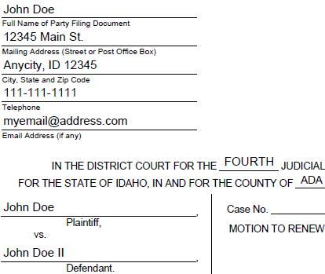

Motion to Renew Judgment. Fill in the information required in the Motion, including the date of the judgment or when it was last renewed, plus the original amount of the judgment. Sign and date the Motion.

Order Renewing Judgment. Fill in the information required in the order, including the date of judgment or when it was last renewed, plus the appropriate renewal period. Leave the date and signature line for the judge blank.

Step Three. Deliver a Copy to the Judgment Debtor. Serve the Motion on the judgment debtor and complete the certificate of service at the end of the motion indicating the manner of service.

Step Four. File the Motion & Order. File the Motion to Renew with the clerk of the court where the judgment was entered, and submit the proposed Order Renewing Judgment for the judge to sign. The clerk will charge you a filing fee for the Motion.

Wait for your copies. If the judge grants the motion, the clerk of the court will mail copies of the signed Order Renewing Judgment to you and the judgment debtor.

